附件2
林业局边步行桥安置房平面图
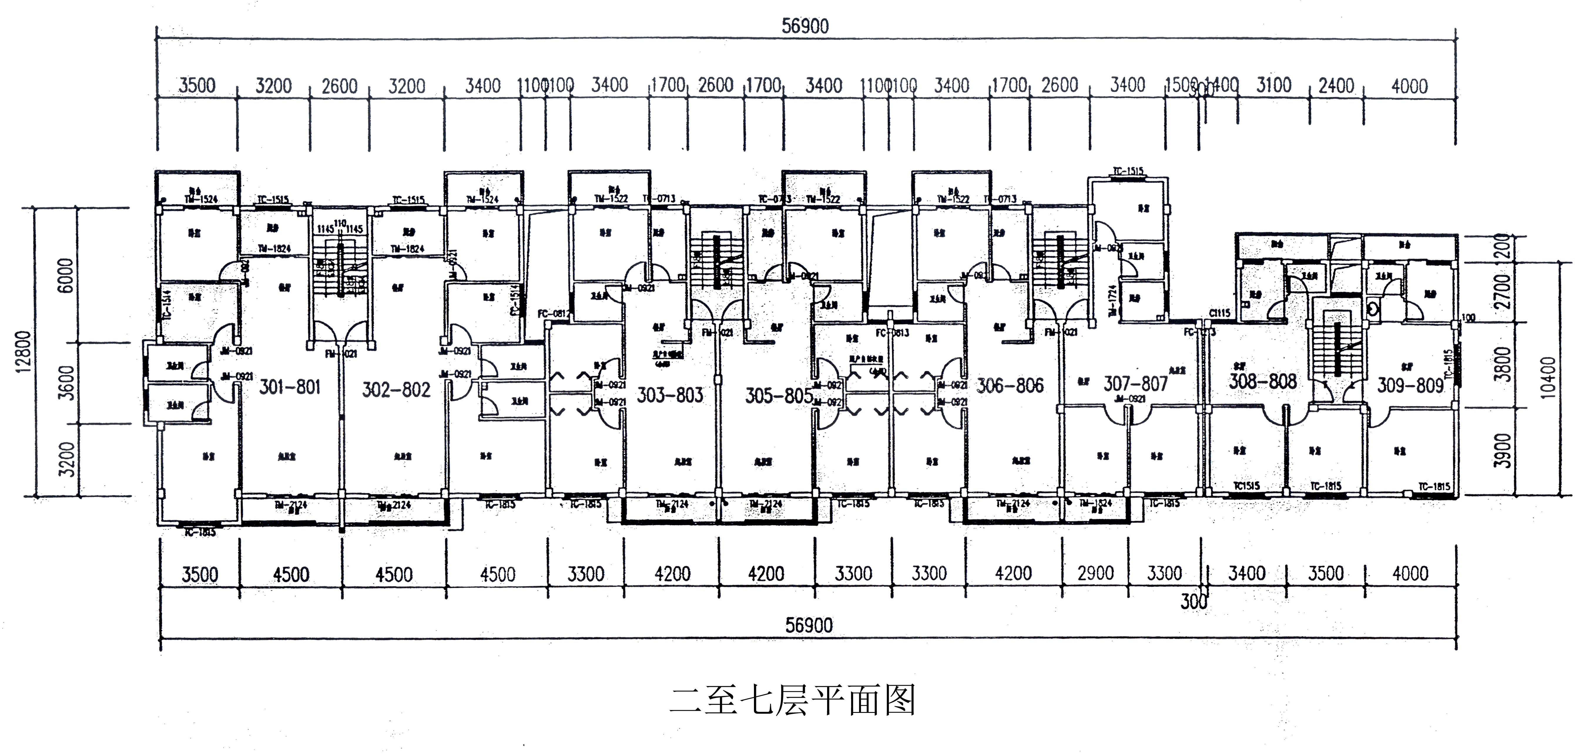

步行桥安置房备选房源情况表
序号 | 层次 | 房号 | 产权面积（m²） | 备注
1 | 6 | 701 | 124.61 | 3套
 | 7 | 801
 | 7 | 802
2 | 1 | 203 | 104.69 | 12套
 | 1 | 205
 | 1 | 206
 | 4 | 506
 | 5 | 605
 | 5 | 606
 | 6 | 703
 | 6 | 705
 | 6 | 706
 | 7 | 803
 | 7 | 805
 | 7 | 806
3 | 1 | 207 | 83.17 | 2套
 | 7 | 807
4 | 1 | 208 | 64.06 | 4套
 | 5 | 608
 | 6 | 708
 | 7 | 808
5 | 1 | 209 | 50.43 | 7套
 | 2 | 309
 | 3 | 409
 | 4 | 509
 | 5 | 609
 | 6 | 709
 | 7 | 809

